**E-TICKET BOOKING SYSTEM**

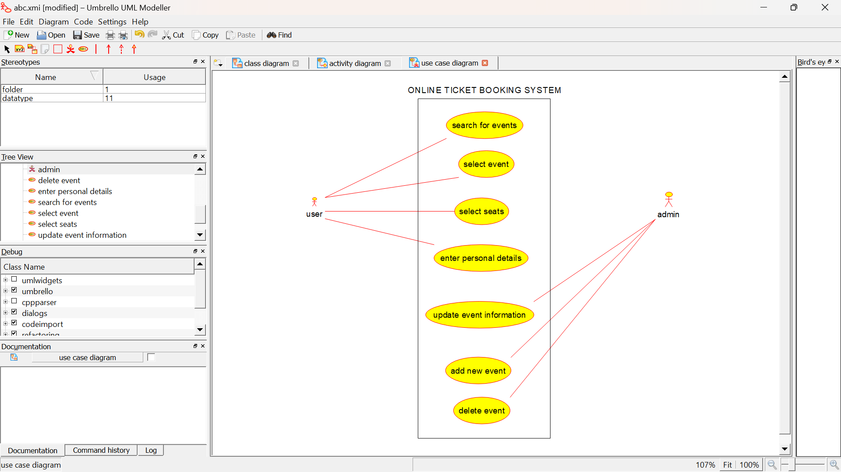

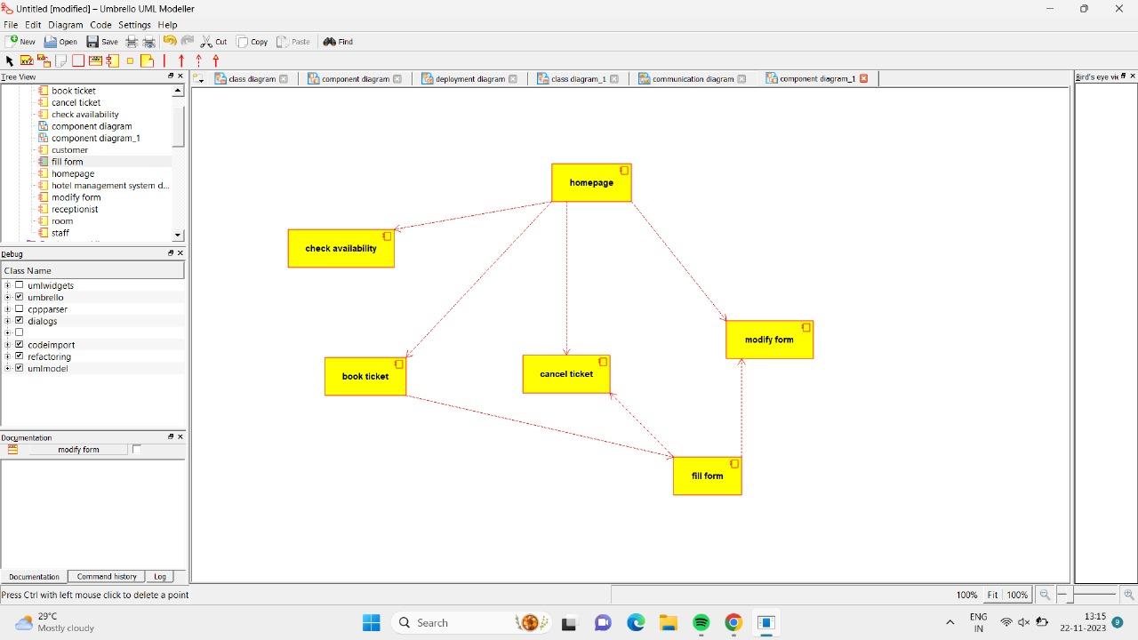

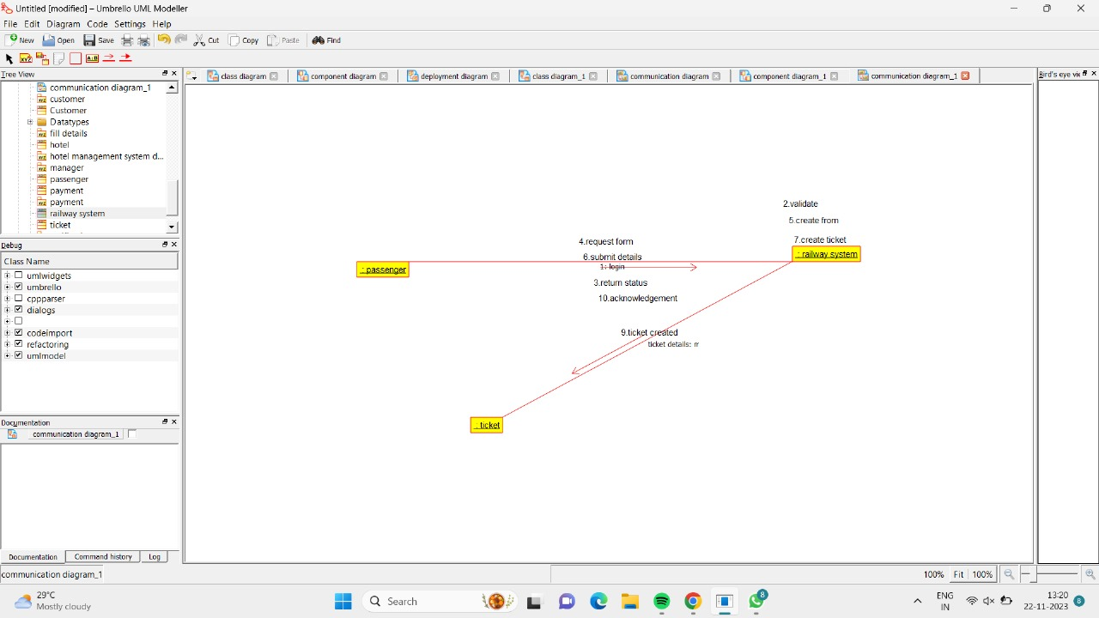

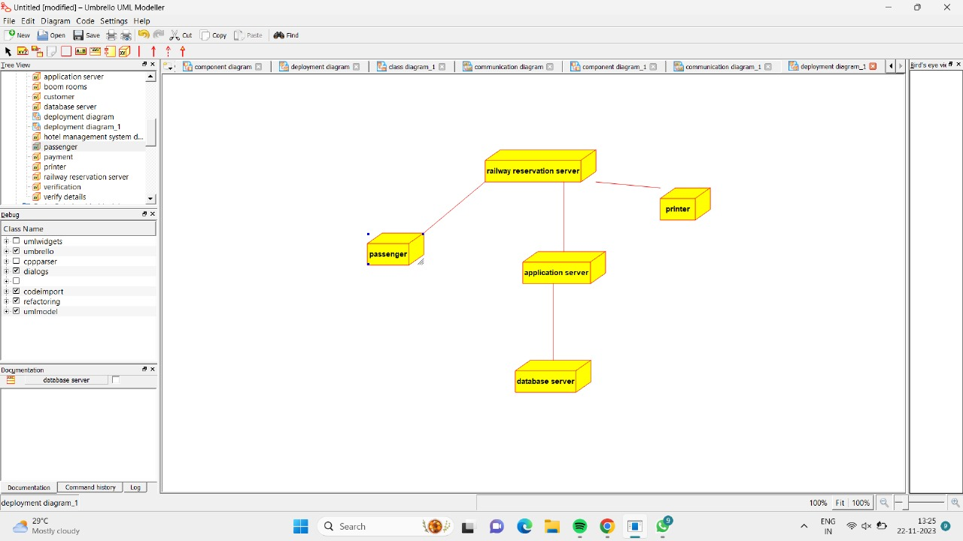

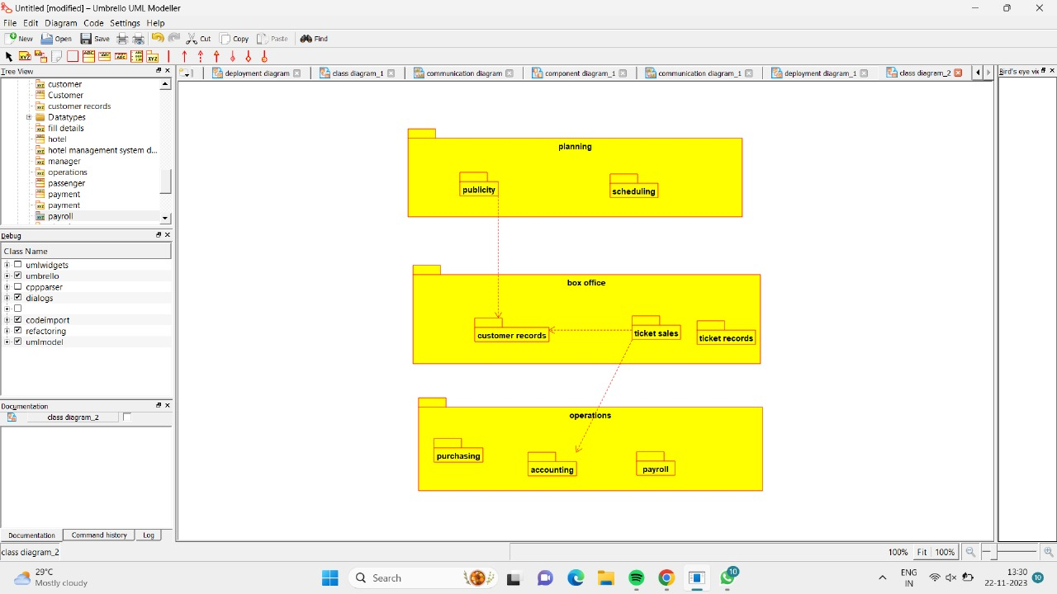

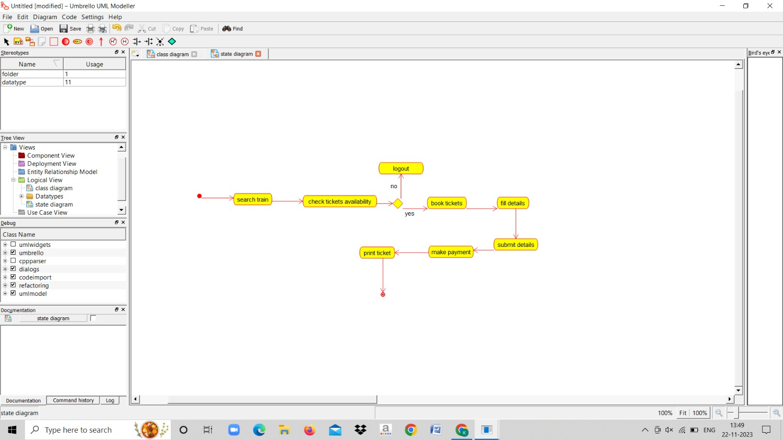

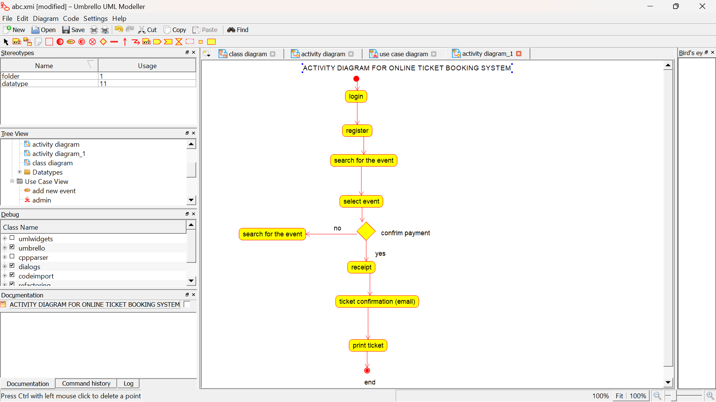

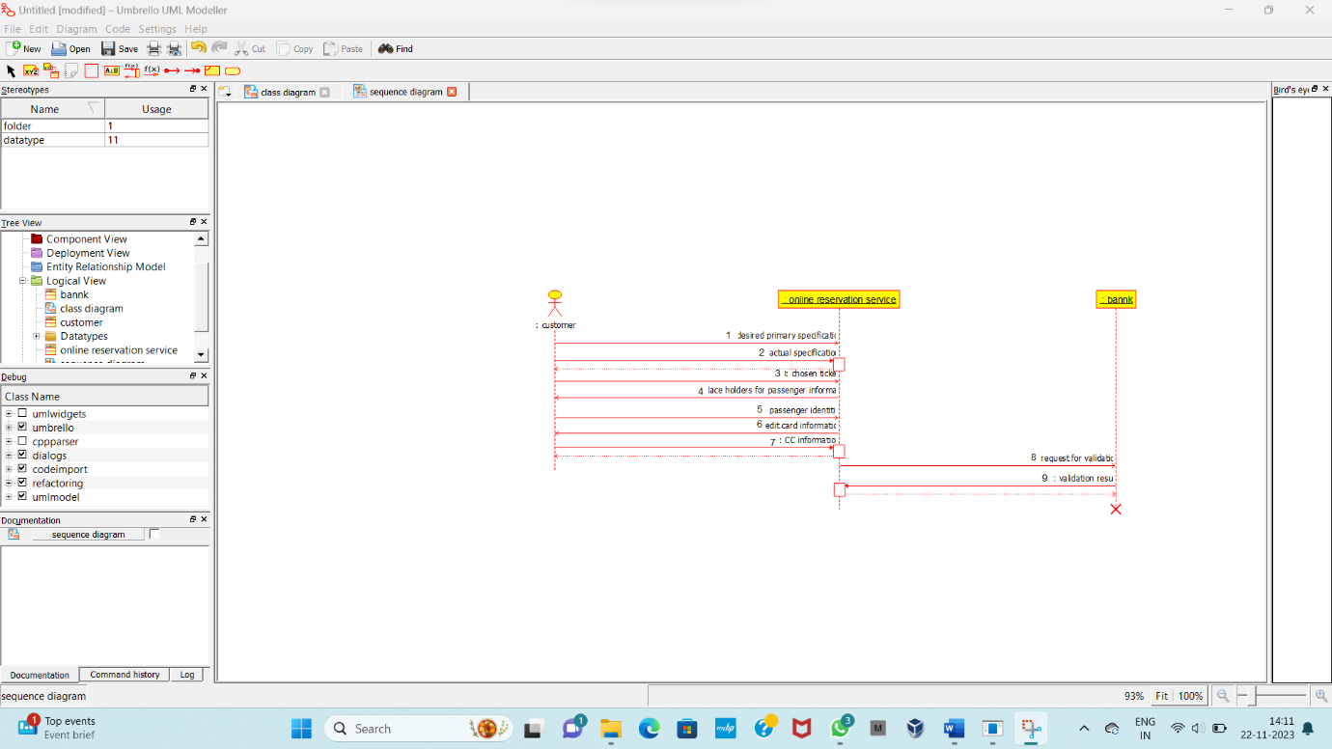

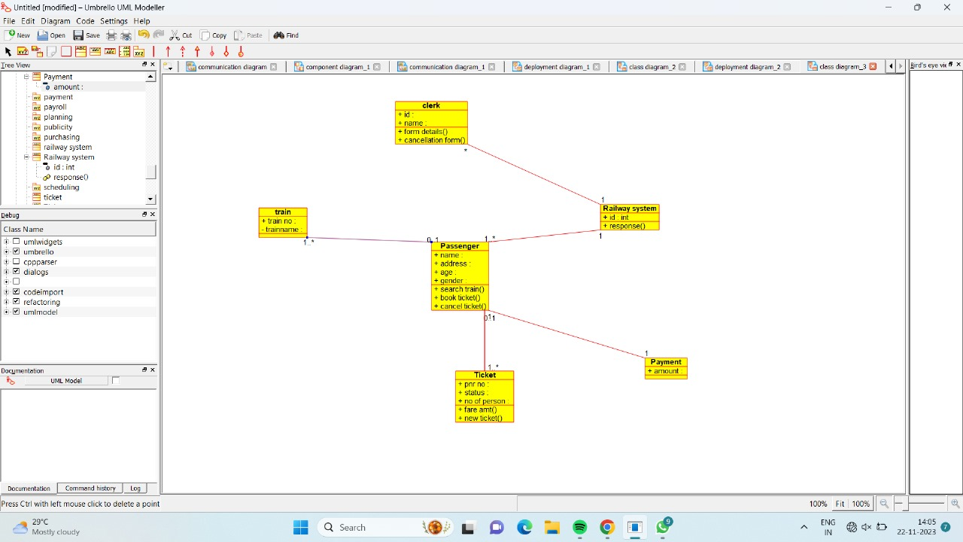

**Skeleton code:**

# coding=System

class ticket(object):

"""

:version:

:author:

"""

""" ATTRIBUTES

pnr_no (private)

status (private)

no_of_persons (private)

"""

def amount(self):

"""

@return :

@author

"""

pass

def new_ticket(self):

"""

@return :

@author

"""

pass

def delete_ticket(self):

"""

@return :

@author

"""

pass